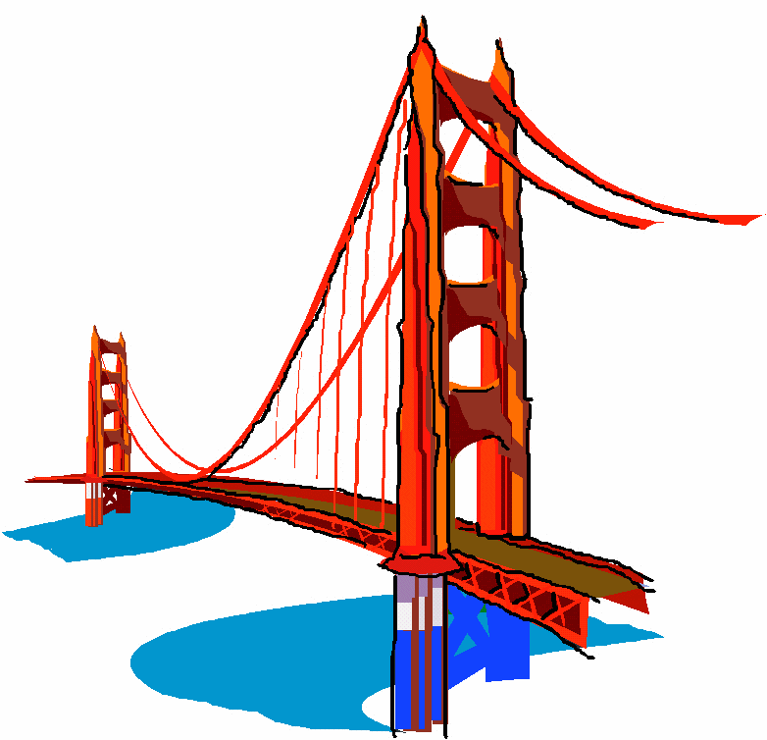San Francisco is the financial, cultural, and transportation center of the San Francisco Bay area, a region of 7.15 million people which includes San Jose and Oakland. The only consolidated city-county in California, it encompasses a land area of about 121 km² on the northern end of the San Francisco peninsula, giving it a density of about 6,632 people per km2. It is the most densely settled large city (population greater than 200,000) in the state of large city in the United States after New tourist destinations in the world, worldwide, and is renowned for eclectic mix of architecture, and Golden Gate Bridge, cable cars, banking and finance center, and California and the second-most densely populated York City. Today, San Francisco is one of the top ranking 33rd out of the 100 most visited cities its chilly summer fog, steep rolling hills, its famous landmarks, including the and Chinatown. The city is also a principal the home to more than 30 International financial institutions, helping to make San Francisco rank eighteenth in the world's top producing cities, ninth in the United States, and thirteenth place in the top twenty global financial centers.